EVSeasonalityCheck.ipynb
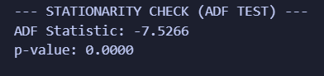
Analysis:
Based on the results of your Augmented Dickey-Fuller (ADF) test, your EV charging station time series is highly stationary.
1. The p-value: 0.0000
- The Rule: In hypothesis testing, a p-value below 0.05 means we reject the null hypothesis.
- The ADF Null Hypothesis: The data is non-stationary (it has a unit root, meaning its statistical properties like mean and variance change over time).
- The Conclusion: Because your p-value is practically zero, you strongly reject the null hypothesis. Your data's mean and variance are stable over time.
2. The ADF Statistic: -7.5266
- The Rule: The more negative this statistic is, the stronger the rejection of the null hypothesis.
- The Conclusion: A value of -7.5266 is an extremely strong negative number, meaning it falls way past the typical critical value thresholds (which usually sit around -3.4 or -2.8). This confirms the p-value's result with high confidence.
What this means for our SARIMA Model?
This is excellent news for your modeling pipeline. Because your data is naturally stationary, you do not need to apply differencing to your dataset.
When you configure your SARIMA (p, d, q) x (P, D, Q, s) model:
- The d (Integration/Differencing) parameter will be 0.
- You can focus entirely on finding the Auto-Regressive (p, P) and Moving Average (q, Q) terms based on your ACF and PACF plots, alongside your seasonal parameter (s, which you identified as a 24-hour daily cycle).

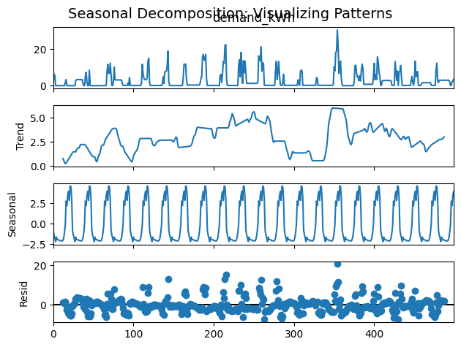
Analysis:
This is the visualization for our forecasting pipeline, plotting the Actual EV charging demand against the predictions from your two models: the PSO Hybrid (SARIMA + PSO-optimized TCN) and the GA Hybrid (SARIMA + GA-optimized TCN).
Here is an analysis of what this plot reveals about your models' performance:
1. Excellent Overall Fit and Generalization
Both hybrid models track the actual data remarkably well across the entire test window (approx. 165 time steps). The models successfully capture both the high-frequency variations and the overarching seasonal wave patterns.
- The y-axis ranges from 0.0 to 1.0, confirming that your data was successfully passed through the MinMaxScaler prior to modeling, which is best practice for neural network inputs like the TCN.
2. Capturing Seasonality and Extremes
Your baseline SARIMA model appears to have done its job by establishing the linear seasonal rhythm. More importantly, both the PSO and GA optimized TCNs effectively predicted the non-linear residuals:
- The Peaks: At the major demand spikes (e.g., around time steps 25, 75, and 125), both models manage to scale up accurately without excessive overshooting.
- The Troughs: The models also accurately track the rapid drop-offs in demand, tightly hugging the actual line during low-usage periods.
3. PSO vs. GA Visual Comparison
Visually, the PSO Hybrid (blue dashed) and GA Hybrid (red dash-dot) are highly competitive, often overlapping each other perfectly.
- If you look closely at some of the micro-fluctuations (for example, between steps 50 and 60, or near step 140), there are very slight deviations where one model might fit the noise slightly better than the other.
- However, because the fits are so tight, it is impossible to definitively declare one optimization algorithm superior strictly through visual inspection.
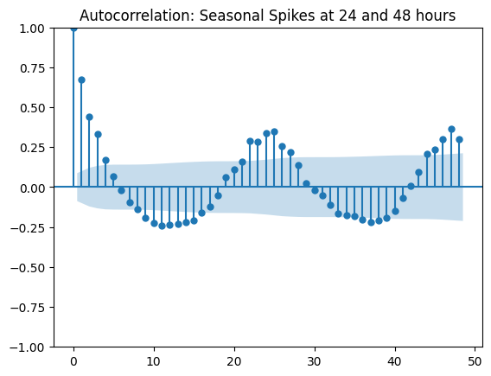
Analysis:
1. Rapid Initial Learning (Epochs 0 to 20)
- Observation: Both the training loss (blue line) and validation loss (orange line) drop steeply and synchronously in the first 10 to 20 epochs.
- Meaning: Your model is successfully and quickly picking up the underlying patterns in the residual data. The optimizer and learning rate (whether from GA, PSO, or your baseline) are well-suited for the initial descent down the error gradient.
2. Convergence (Epochs 20 to 40)
- Observation: The steep drop levels off, and the curves begin to flatten out.
- Meaning: The model has essentially converged. By epoch 30 or 40, it has learned almost everything it can to generalize well on the validation set.
3. Mild Overfitting in the Late Stages (Epochs 40 to 100)
- Observation: After epoch 40, the training loss continues a very slow, gradual creep toward zero. However, the validation loss plateaus and stops improving, creating a visible and widening "gap" between the two lines.
- Meaning: This divergence is the textbook visual signature of mild overfitting. Because the training loss keeps dropping while the validation loss does not, the model is starting to memorize the specific noise in the training set rather than learning generalizable patterns. Fortunately, the validation loss is only plateauing (and fluctuating slightly) rather than spiking sharply upwards, so the overfitting isn't severe, but the extra training time isn't adding value.

